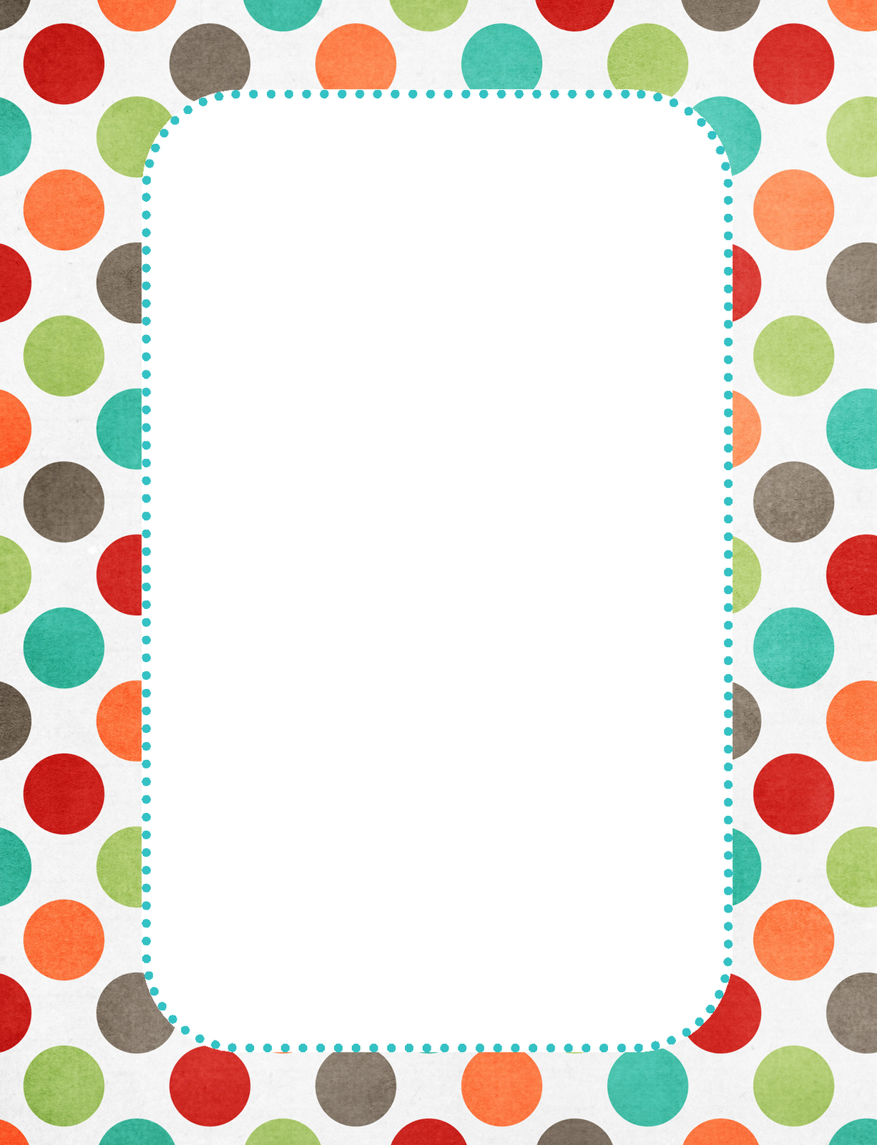

Baby Boy Clothes

Newborn

Baby Boy Clothes

3 Months

Baby Boy Clothes

6 Months

Baby Boy Clothes

9 Months

Baby Boy Clothes
12 Months & Up

Baby Blankets

